Monday | Tuesday | Wednesday | Thursday | Friday | Saturday
 | 5:35 – 6:30 AM  P.U.M.P  All Levels  Grace |  | 5:35 – 6:30 AM  X-TRAIN  All Levels  Grace |  | 9:30 – 10:30 AM  P.U.M.P  All Levels  T.B.A.
5:30 – 6:30 PM  P.U.M.P  Beg. / Int.  Grace | 5:30 – 6:30 PM  X-TRAIN  All Levels  Grace | 5:30 – 6:30 PM  P.U.M.P  Beg. / Int.  Grace | 5:30 – 6:30 PM  BODYBLAST  All Levels  Jaclyn | 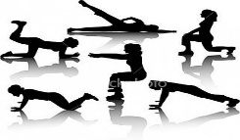  5:30 – 6:30 PM  CIRCUIT  All Levels  Grace
6:45 – 7:45 PM  BOOTCAMP  *  All Levels  Grace | 6:35 – 7:30 PM  CARDIO  All Levels  Grace | 6:45 – 7:45 PM  BOOTCAMP  *  All Levels  Grace | 6:35 – 7:30 PM  FIGHT  All Levels  Grace | Fee Schedule  Drop In: $10  6 Class Pass: $48  12 Class Pass: $84  24 Class Pass: $156  40 Class Pass: $240
8:00 – 8:30 PM  B.L.T.  (Buns, Legs & Tummies)  All Levels  Grace | 7:35 – 8:45 PM  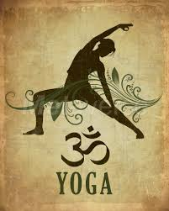  All Levels  Grace | 8:00 – 9:00 PM  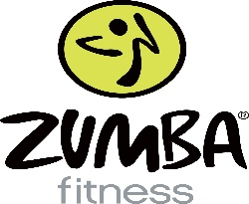  All Levels  Grace / Maryna | 7:35 – 8:45 PM  All Levels  Grace

Training levels are based on degrees of choreography complexity. Classes marked with a (*) are of a higher intensity!
All instructors are provincially and/or internationally certified!
Schedule of classes subject to change based on class attendance, statutory holidays and/or facility restrictions.

We are located at the Servus Sports Centre
5202 – 12th Street; 2nd Floor
Fitness Training Room
E-mail Grace for more info at
grace@nrg4life.ca
Join our NRG 4 Life
Facebook page

